Photodiode

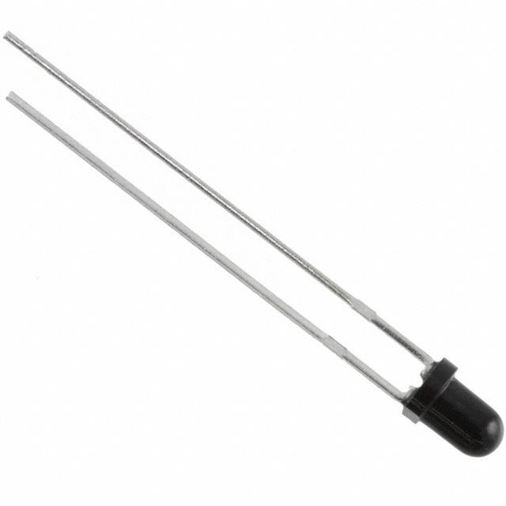

One potential option is EVERLIGHT 3mm Photodiode. Data Sheet with light data and expected dark current found at: http://www.everlight.com/file/ProductFile/PD204-6B.pdf

This Light intensity varying diode will be used to measure the temperature on Mars.

# Circuit

The circuit operates the photodiode in photovoltaic mode, where the op amp keeps the voltage across the photodiode at 0 V. photodiode outputs a small current even if there is no light present. This dark current grows with increasing reverse voltage across the photodiode. Ideally, all of the photodiode current flows through the feedback resistor, generating an output voltage equal to the photodiode current multiplied by the feedback resistor. 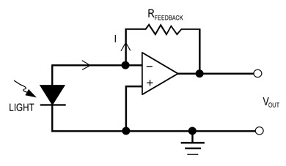

Figure 1: Photodiode Circuit

# Photovoltaic Mode

“When used in zero [bias](https://en.wikipedia.org/wiki/Bias_(electrical_engineering)) or *photovoltaic mode*, the flow of photocurrent out of the device is restricted and a voltage builds up. This mode exploits the [photovoltaic effect](https://en.wikipedia.org/wiki/Photovoltaic_effect), which is the basis for [solar cells](https://en.wikipedia.org/wiki/Solar_cell) – a traditional solar cell is just a large area photodiode.”

* wikipedia.org

# Typical Transfer Function

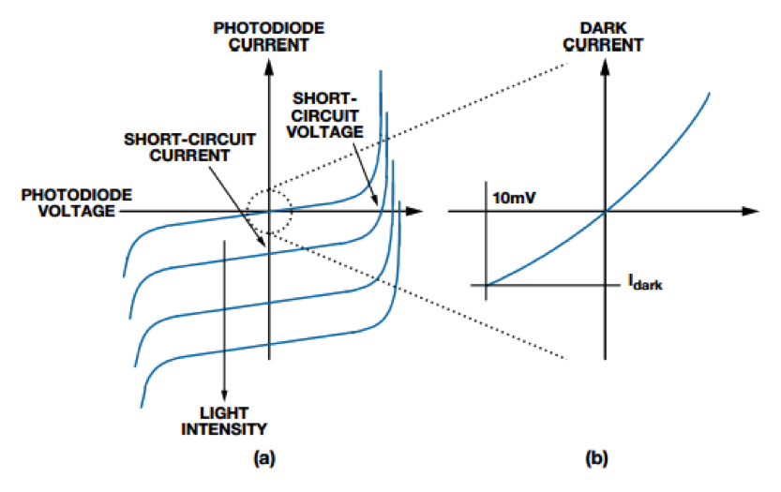

Figure 2: Typical Photodiode function

# Circuit Equation

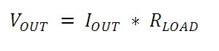

Figure 3: Current to Voltage Amplifier Gain Formula

The actual code for turning these voltages into usable data will need a lookup table with the data found in the datasheet. This is required because of the slight non-linearity of the device.